
MULUNGUSHI UNIVERSITY
SCHOOL OF ENGINEERING AND TECHNOLOGY (SET)

NAME: CHABOTA SIYINGWA
STUDENT NO: 202407073
PROGRAM: INFORMATION TECHNOLOGY
YEAR OF STUDY : SECOND YEAR
COURSE : DATA STRUCTURE
COURSE CODE : ICT 202

WORKFLOW:
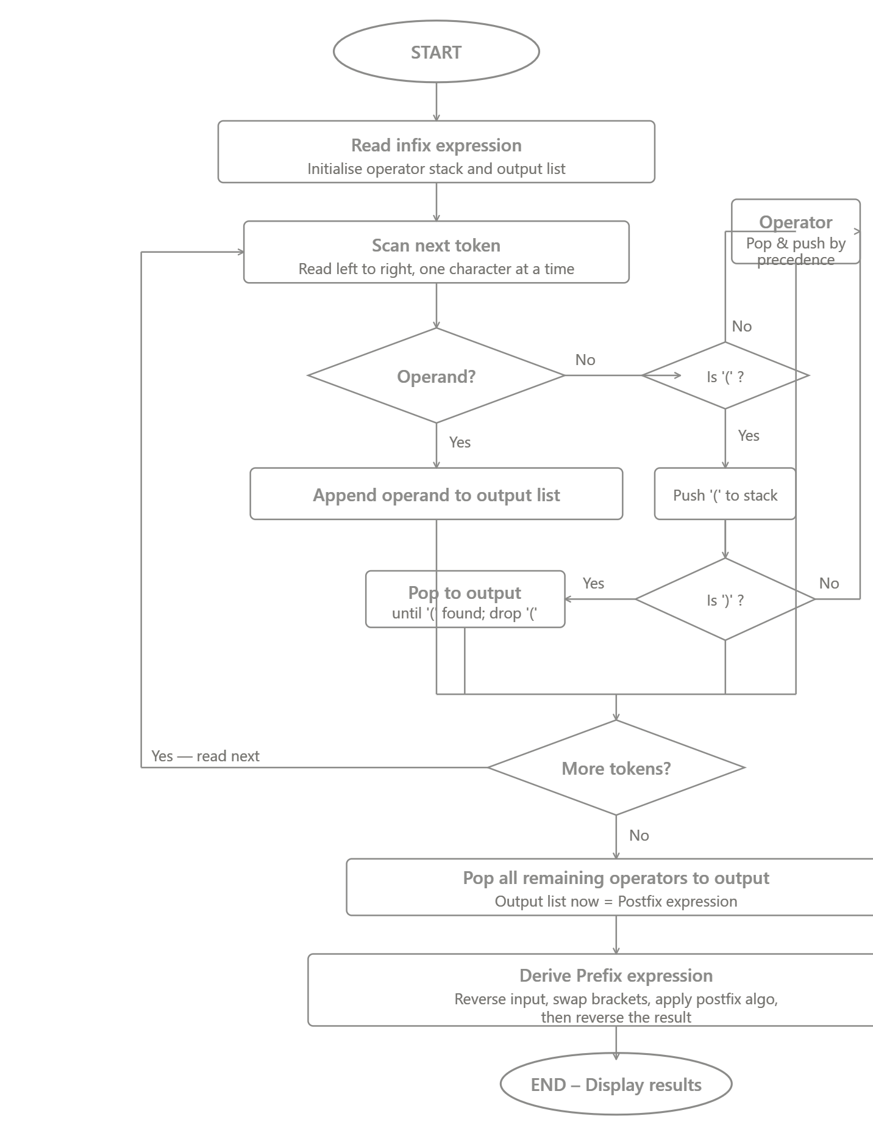
PSEUDO CODE:
FUNCTION infixToPostfix(expression):
stack ← empty stack
output ← empty list

FOR each token IN expression:
IF token is an operand:
output.append(token)

ELSE IF token == '(':
stack.push(token)

ELSE IF token == ')':
WHILE stack.top() != '(':
output.append(stack.pop())
stack.pop() // discard '('

ELSE token is an operator:
WHILE stack is not empty
AND stack.top() != '('
AND precedence(stack.top()) >= precedence(token):
output.append(stack.pop())
stack.push(token)

WHILE stack is not empty:
output.append(stack.pop())

RETURN output joined as string

JAVA PROGRAM:
import java.util.Stack;
public class InfixConverter {
private static int precedence(char op) {
if (op == '^') return 3;
if (op == '*' || op == '/') return 2;
if (op == '+' || op == '-') return 1;
return 0; }
private static boolean isOperand(char c) {
return Character.isLetterOrDigit(c);
}
// ── Infix → Postfix
public static String infixToPostfix(String expr) {
StringBuilder output = new StringBuilder();
Stack<Character> stack = new Stack<>();
for (char token : expr.toCharArray()) {
if (token == ' ') continue;
if (isOperand(token)) {
output.append(token);
} else if (token == '(') {
stack.push(token);
} else if (token == ')') {
while (!stack.isEmpty() && stack.peek() != '(') {
output.append(stack.pop());
}
if (!stack.isEmpty()) stack.pop(); // remove '('
} else { // operator
while (!stack.isEmpty()
&& stack.peek() != '('
&& precedence(stack.peek()) >= precedence(token)) {
output.append(stack.pop());
}
stack.push(token);
}
}
while (!stack.isEmpty()) {
output.append(stack.pop());
}
return output.toString();
}
// ── Infix → Prefix
public static String infixToPrefix(String expr) {
// Step 1: reverse the expression
String reversed = new StringBuilder(expr).reverse().toString();

// Step 2: swap brackets
StringBuilder swapped = new StringBuilder();
for (char c : reversed.toCharArray()) {
if (c == '(') swapped.append(')');
else if (c == ')') swapped.append('(');
else swapped.append(c);
}
// Step 3: convert to postfix
String postfix = infixToPostfix(swapped.toString());
// Step 4: reverse postfix → prefix
return new StringBuilder(postfix).reverse().toString();
}
public static void main(String[] args) {
String[] testCases = {
"A+B*C",
"(A+B)*(C-D)",
"A+B*(C^D-E)^(F+G*H)-I"
};

System.out.printf("%-30s %-20s %-20s%n", "Infix", "Postfix", "Prefix");
System.out.println("-".repeat(70));

for (String expr : testCases) {
String postfix = infixToPostfix(expr);
String prefix = infixToPrefix(expr);
System.out.printf("%-30s %-20s %-20s%n", expr, postfix, prefix);
}
}
}

